HTML ASSIGNMENT-I

1. Write a HTML for the following screen.

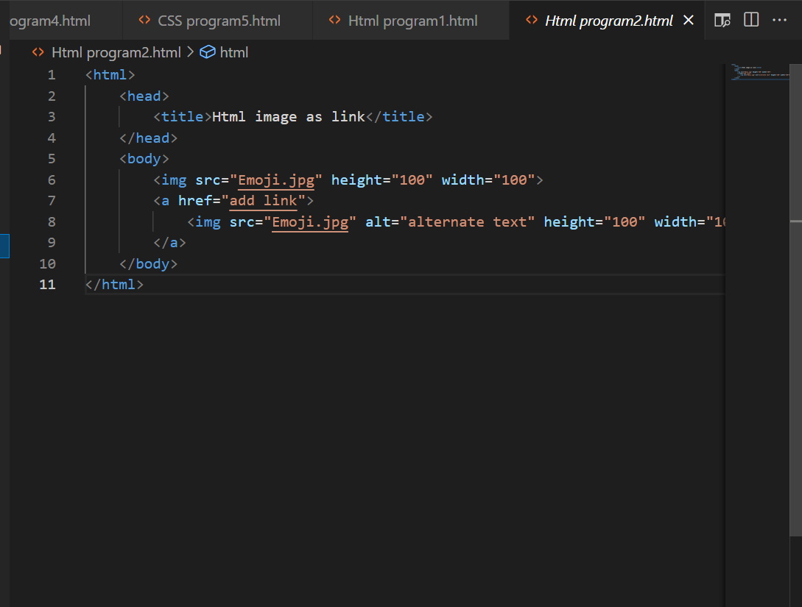  
Output:

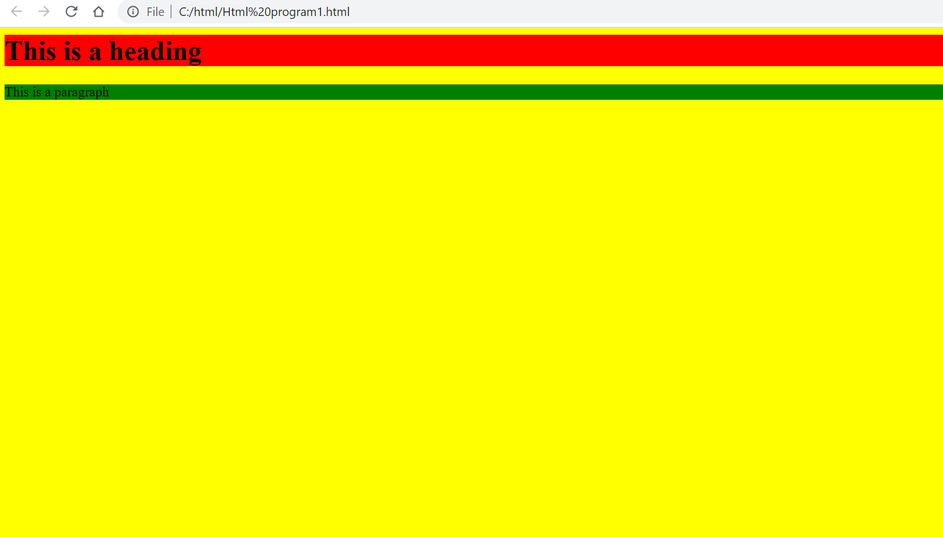

1. Write HTML for the following text and images below? The first image has a square border and the second image has no border.

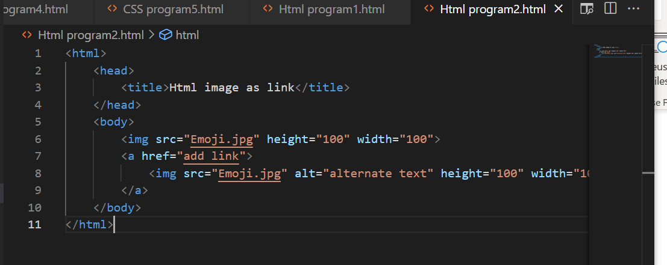

Output:

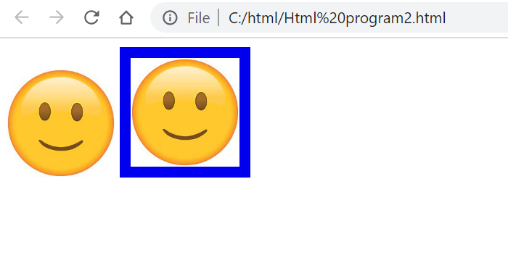

1. Each table starts with a table tag. Each table row starts with a tr tag. Each table data starts with a td tag.

One column:

100

One row and three columns:

100 200 300

Two rows and three columns:

100 200 300

400 500 600

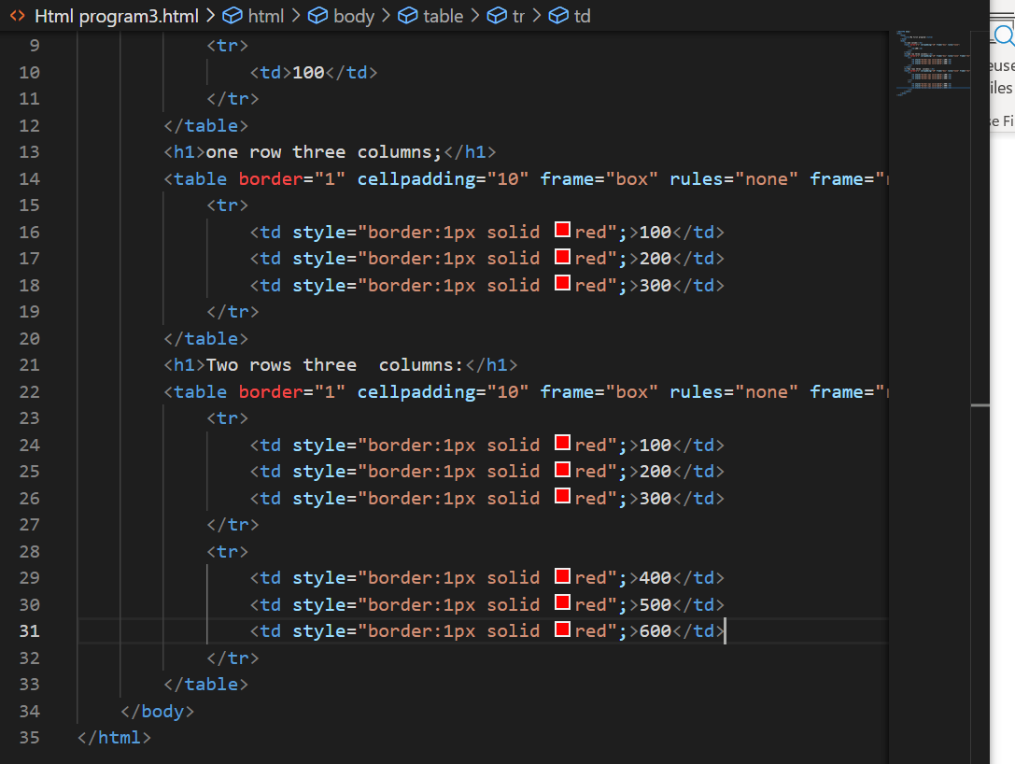

Output:

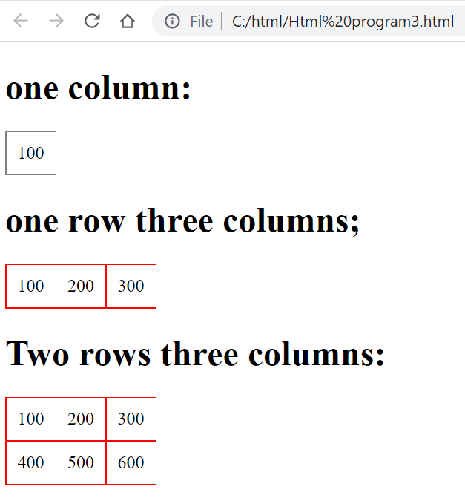

1. Write the HTML for the following text. Do not consider the outermost border:

This table has borders:

100 200 300

400 500 600

And this table has no borders:

100 200 300

400 500 600

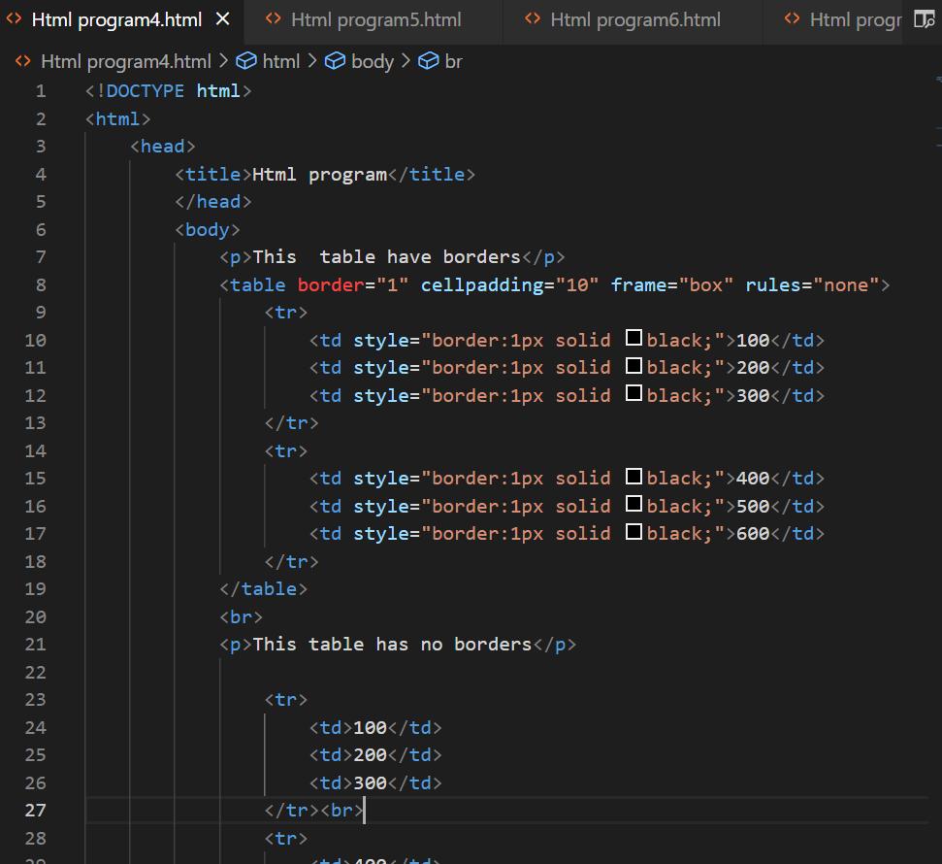

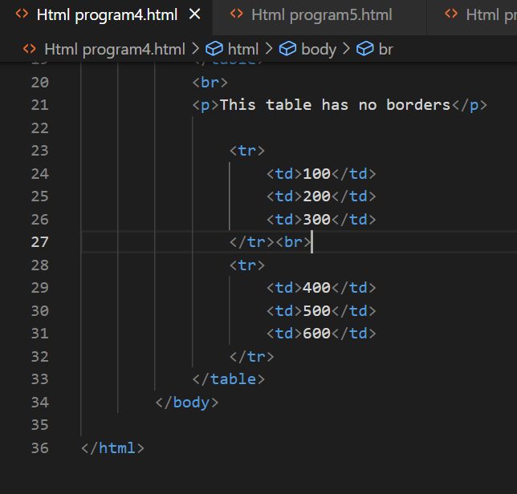

Output:

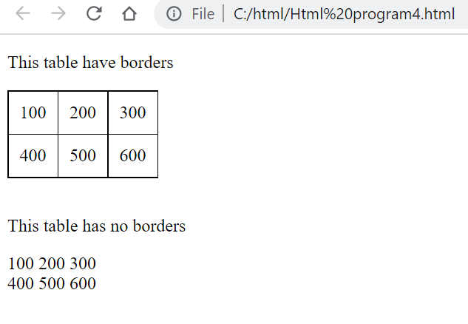

1. Write the html for the following text. Do not consider the outermost border:

Numbered list:

1. Apples
2. Bananas
3. Lemons
4. Oranges

Letters list:

1. Apples
2. Bananas
3. Lemons
4. Oranges

Lowercase letters list:

1. Apples
2. Bananas
3. Lemons
4. Oranges

Roman numbers list:

1. Apples
2. Bananas
3. Lemons
4. Oranges

Lowercase Roman numbers list:

1. Apples
2. Bananas
3. Lemons
4. Oranges

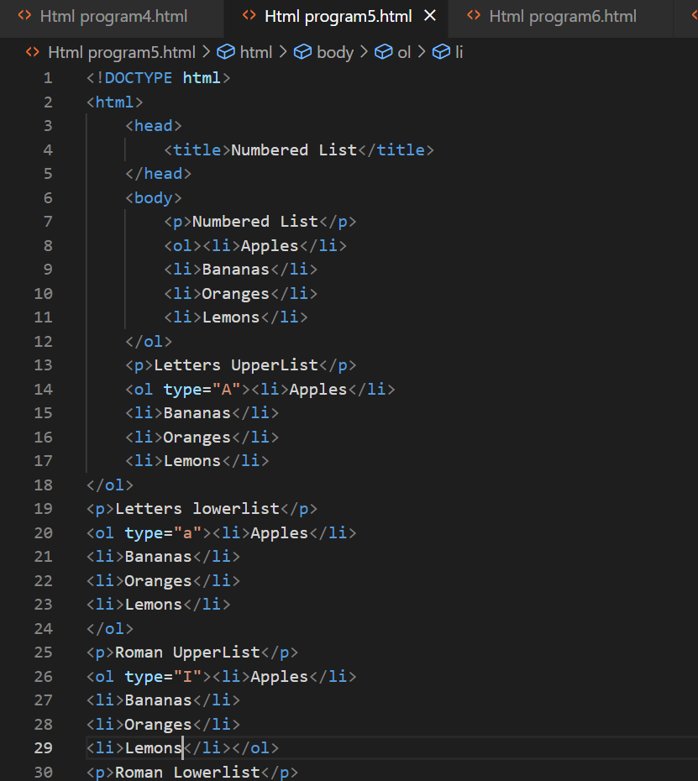

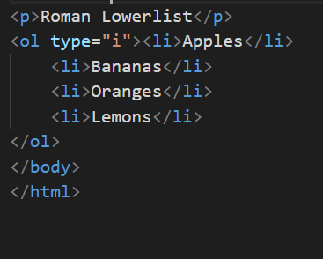

Output:

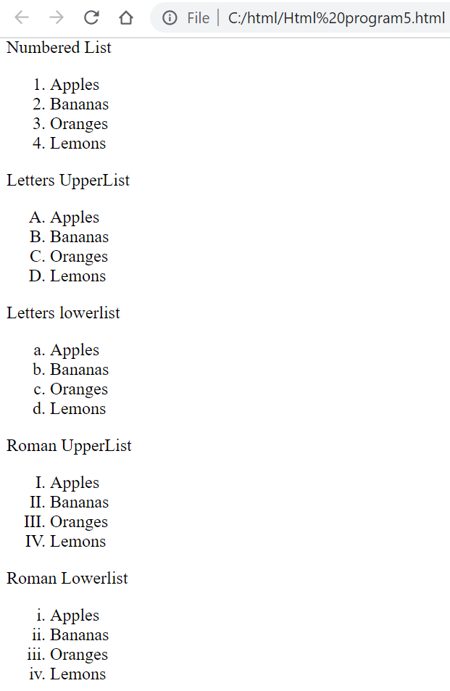

1. Write a HTML for the following image shown below. Note: The characters in a password field are masked. Do not consider the outermost border:

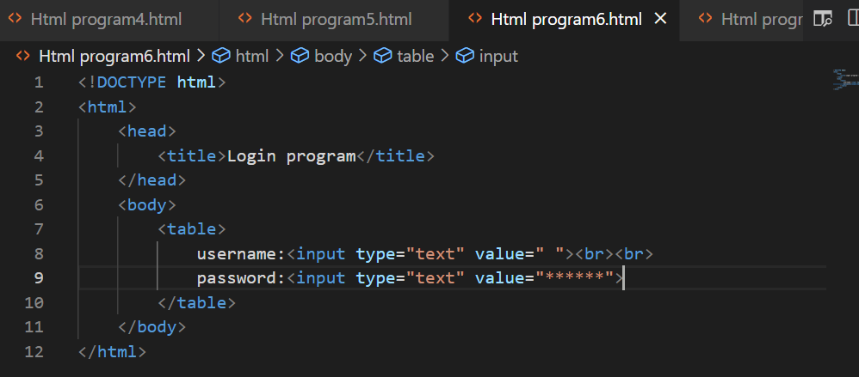

Output:

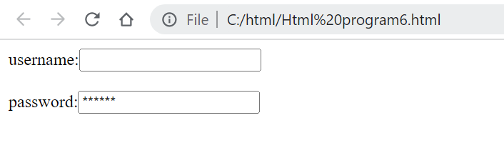

1. Write the html for the following image shown below. Do not consider the outermost border:

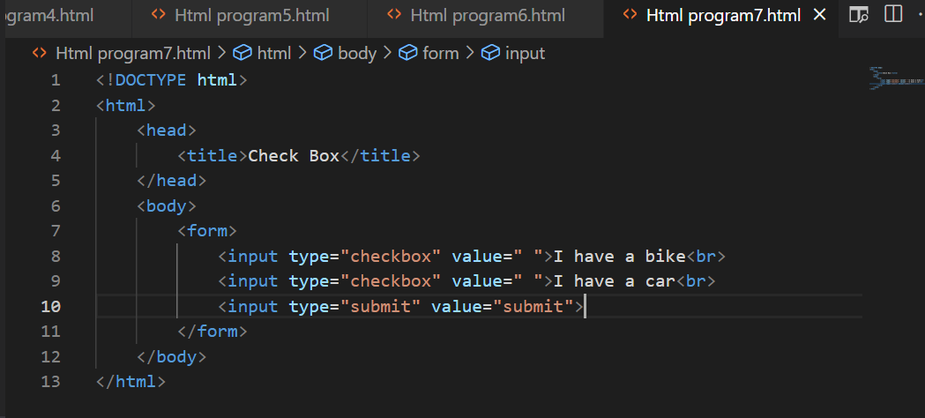

Output:

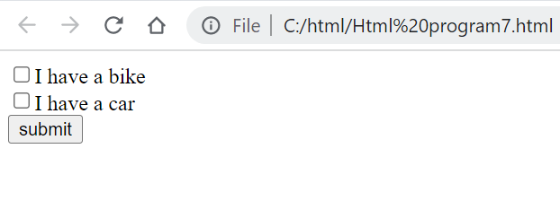

1. Write the HTML for the following image shown below. Do not consider the outermost border:

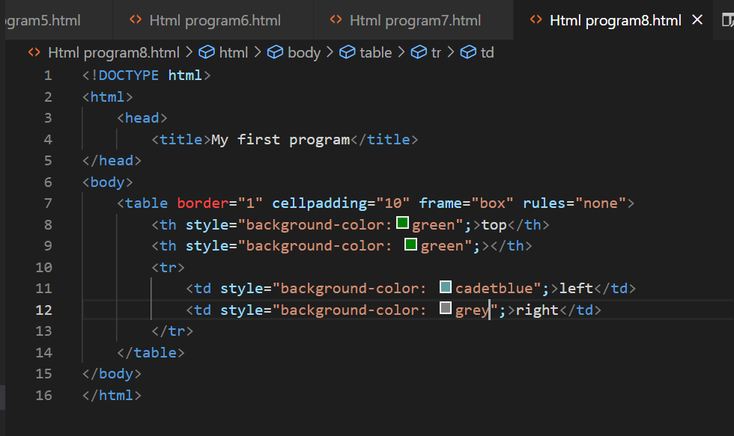

Output:

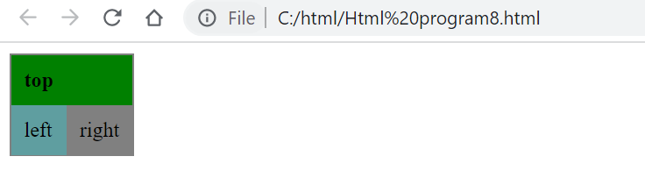

1. 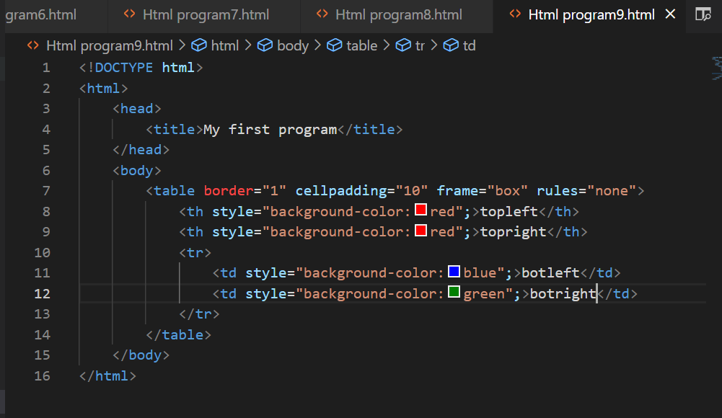

Output:

